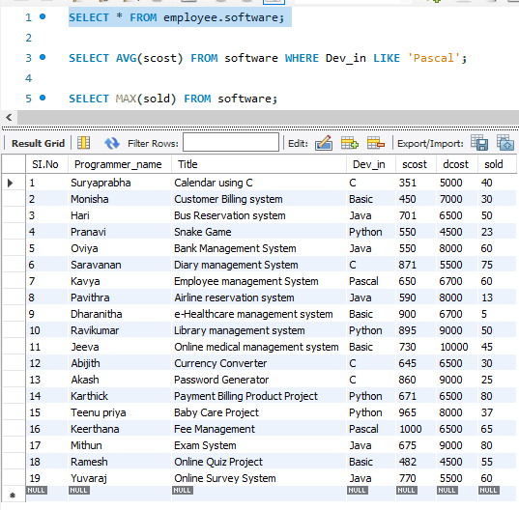

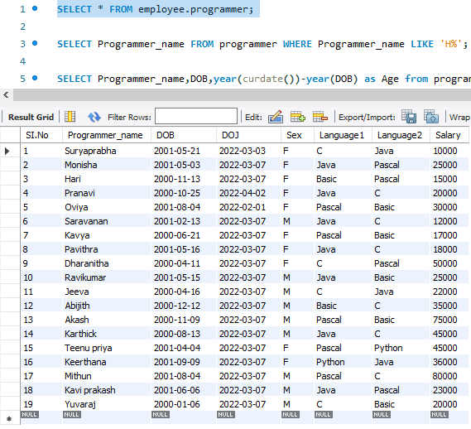

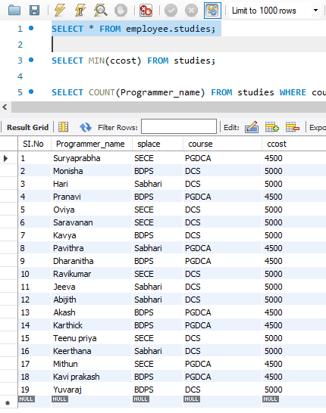

**QUERIES-1**

1) Find out the SELLING COST AVERAGE for the packages developed in PASCAL?

SELECT AVG (SCOST) FROM SOFTWARE WHERE DEV_IN LIKE 'PASCAL';

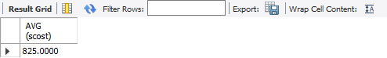

2) Display the names and ages of all programmers.

SELECT Programmer_name, DOB, year(curdate())-year(DOB) as Age from programmer;

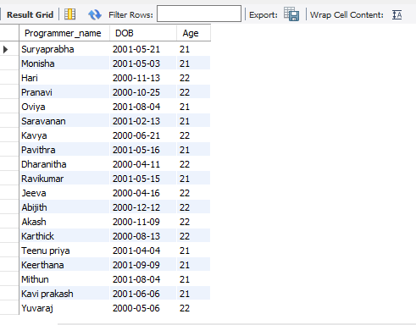

3) Display all the programmers whose name end with H?

SELECT Programmer_name FROM programmer WHERE Programmer_name LIKE 'H%';

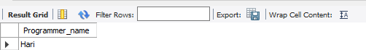

4) What is the highest numbers of copies sold by a package?

SELECT sold from software order by sold desc limit 0,1;

(OR)

SELECT MAX(sold) FROM software;



5) Display the names and date of birth of all the programmer born in JANUARY.

SELECT Programmer_name,DOB FROM programmer where MONTH(DOB) = 1;

(OR)

SELECT Programmer_name, DOB FROM programmer where DATENAME(mm,dob) = 'January';

SELECT Programmer_name, DOB FROM programmer where DATEPART(mm,dob) = 1;

The above query is used when we use datepart datatype while defining the table.

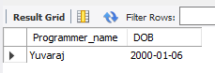

6) Display lowest course fee.

SELECT MIN(ccost) FROM studies;

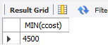

7) How many programmer has done PGDCA course.

SELECT COUNT(Programmer_name) FROM studies WHERE course LIKE 'PGDCA';



8) How much revenue has been earned through sales of packages in C.

SELECT SUM(sold*scost) FROM software WHERE Dev_in LIKE 'C';

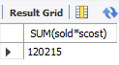

9) Display the details of software developed by Ramesh?

SELECT * FROM software WHERE Programmer_name LIKE 'Ramesh';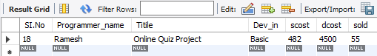

10) How many programmers studied at SABHARI.

SELECT COUNT(Programmer_name) FROM studies WHERE splace LIKE 'Sabhari';



11) Display the details of PACKAGES whose sales crossed the 20000 mark.

SELECT * FROM software WHERE (sold*scost)>20000;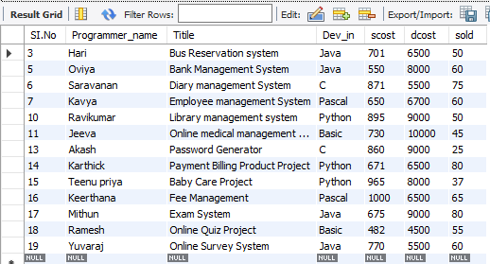

12) Find out the number of copies which should be sold in order to recover the development costof each package.

SELECT ROUND(dcost/scost) FROM software WHERE (scost*sold)<dcost;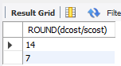

13) What is the price of the costliest software developed in BASIC?

SELECT MAX(scost) FROM software WHERE Dev_in LIKE 'BASIC';



14) Display the details of packages for which development cost has been recovered.

SELECT * FROM software WHERE (scost*sold)<dcost;

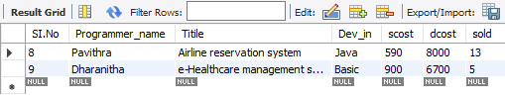

15) How many packages were developed in dbase?

SELECT COUNT(Title) AS Total_projects_in_dbase FROM software WHERE Dev_in='DBASE';

16) How many programmers studies at paragathi?

SELECT COUNT(Programmer_name) FROM studies WHERE splace LIKE 'Paragathi';

(OR)

SELECT COUNT(Programmer_name) FROM studies WHERE splace= 'Paragathi';



17) How many programmers paid 5000 to 10000 for their course?

SELECT COUNT(Programmer_name) AS No_Of_Programmers FROM studies WHERE ccost>=5000 AND ccost<=10000;

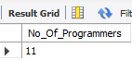

18) What is the average course fee?

SELECT AVG(ccost) FROM studies;



19) Display the details of programmers knowing c?

SELECT COUNT(Programmer_name) AS No_Of_Programmers FROM programmer WHERE Language1='C' OR Language2='C';

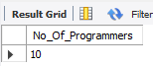

20) How many programmers know either Cobol or Pascal?

SELECT COUNT(Programmer_name) AS No_Of_Programmers FROM programmer WHERE Language1 IN ('COBOL','PASCAL' ) OR Language2 IN ('COBOL' ,'PASCAL' );



21) How many programmers don't know Pascal & C?

SELECT COUNT(Programmer_name) AS No_Of_Programmers FROM programmer WHERE Language1 NOT IN ('C','PASCAL') AND Language2 NOT IN ('C','PASCAL');

22) How old is the oldest male programmers?

SELECT MAX(FLOOR(DATEDIFF(CURDATE(),DOB)/365)) FROM programmer WHERE Sex ='M';



23) What is the average age of female programmers?

SELECT FLOOR(AVG(DATEDIFF(CURDATE(),DOB)/365)) FROM programmer WHERE Sex = 'F';

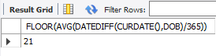

24) Calculate the experience in years for each programmers and display along with the names in descending order?

SELECT Programmer_name,FLOOR((CURDATE(),DOJ)/365) AS Experience FROM programmer ORDER BY Programmer_name DESC;

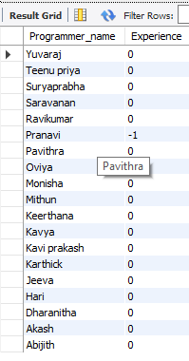

25) Who are the programmers who celebrate their birthday during the current month?

SELECT Programmer_name FROM PROGRAMMER WHERE MONTH (DOB) = MONTH(CURDATE());

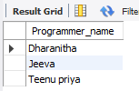

26) How many female programmers are there?

SELECT COUNT(Programmer_name) Female_programmer FROM programmer WHERE Sex='F';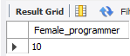

27) What are the languages known by the male programmers?

SELECT DISTINCT Language1,Language2 FROM programmer WHERE Sex='M';

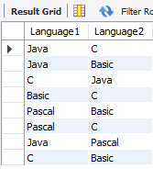

28) What is the Average salary?

SELECT AVG(Salary) AS Average_Salary FROM programmer;

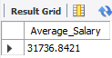

29) How many people draw 2000 to 4000?

SELECT Programmer_name FROM programmer WHERE Salary BETWEEN 2000 AND 4000;

30) Display the details of those who don't know Clipper, Cobol or Pascal?

SELECT * FROM PROGRAMMER WHERE Language1 NOT IN ('CLIPPER','COBOL','PASCAL') AND Language2 NOT IN ('CLIPPER','COBOL','PASCAL');



31) How many Female programmers knowing C are above 24 years of age?

SELECT COUNT(Programmer_name) AS NO_of_Female_Programmer FROM PROGRAMMER WHERE SEX='F' AND (Language1='C' OR Language2='C') AND (DATEDIFF(CURDATE(),DOB)/365) > 24;

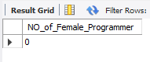

32) Who are the programmers who will be celebrating their Birthday within a week?

SELECT Programmer_name FROM PROGRAMMER WHERE WEEK(DOB) = WEEK(CURDATE());

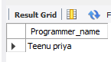

33 Display the details of those with less than a year's experience?

SELECT * FROM programmer WHERE FLOOR(DATEDIFF(CURDATE(),DOJ)/365)<1;

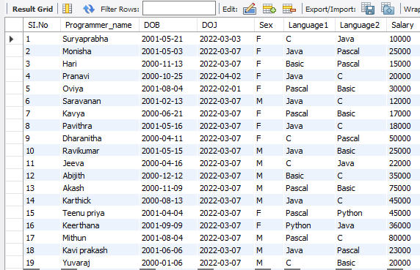

34) Display the details of those who will be completing 2 years of service this year?

SELECT Programmer_name FROM programmer WHEREFLOOR(DATEDIFF(CURDATE(),DOJ)/365)=2;

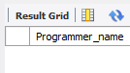

35) Calculate the amount to be recovered for those packages whose development cost has not been recovered?

SELECT (DCOST-(SCOST*SOLD)),TITLE FROM SOFTWARE WHERE (SCOST*SOLD);

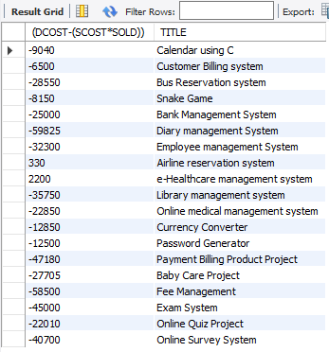

36) List the packages which have not been sold so far?

SELECT * FROM software WHERE sold=0;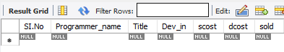

37) Find out the cost of the software developed by Kavya?

SELECT Title, scost AS Software_cost FROM software WHERE Programmer_name='Kavya';



38) Display the institutes names from the studies table without duplicates?

SELECT DISTINCT splace FROM studies;

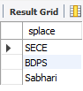

39) How many different courses are mentioned in the studies table?

SELECT DISTINCT course FROM studies;

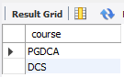

40) Display the names of the programmers whose names contain 2 occurrences of the letter A?

SELECT Programmer_name FROM Programmer WHERE Programmer_name LIKE '%A%A%';

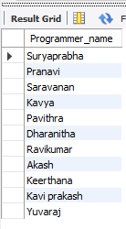

41) Display the names of programmers whose names contain upto 5 characters?

SELECT Programmer_name FROM Programmer WHERE LENGTH(Programmer_name)=5;

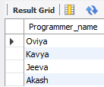

42) How many female programmers knowing COBOL have more than 2 years experience?

SELECT COUNT(Programmer_name) AS Cobol_Experience FROM programmer WHERE FLOOR(DATEDIFF(CURDATE(),DOJ)/365)>2 AND Sex='F' AND (Language1='COBOL' OR Language2='COBOL');



43) What is the length of the shortest name in the programmer table?

SELECT MIN(LENGTH(Programmer_name)) AS Minimum_Length_name FROM programmer;

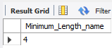

44) What is the average development cost of a package developed in COBOL?

SELECT AVG(dcost) FROM software WHERE Dev_in='COBOL';

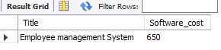

45) Display the name, sex, dob (DD/MM/YY format), doj for all the programmers without using

conversion function?

SELECT NAME, SEX, SUBSTR(DOB,1,2) ||'/'||SUBSTR(DOB,4,3) ||'/'||SUBSTR(DOB,8,2) DOB, SUBSTR(DOJ,1,2) ||'/'||SUBSTR(DOJ,4,3) ||'/'||SUBSTR(DOJ,8,2) DOJ FROM PROGRAMMER;

46) Who are the programmers who were born on the last day of the month?

SELECT Programmer_name FROM programmer WHERE LAST_DAY(DOB) = DOB;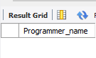

47) What is the amount paid in salaries of the male programmers who do not know Cobol?

SELECT Salary FROM programmer WHERE Sex='M' AND (Language1 !='COBOL' OR Language2 !='COBOL');

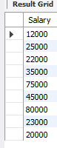

48) Display the title, scost, dcost and difference between scost and dcost in descending order of

difference?

SELECT Title, scost, dcost,dcost-scost DIFF FROM software ORDER BY 4 DESC;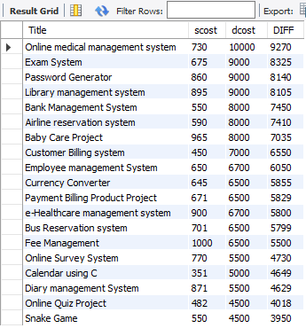

49) Display the name, dob, doj of those month of birth and month of joining are same?

SELECT NAME FROM PROGRAMMER WHERE TO_CHAR(DOB,'MM') =TO_CHAR(DOJ,'MM');

50) Display the names of the packages whose names contain more than 1 word?

SELECT Title FROM software WHERE Title LIKE '% %';

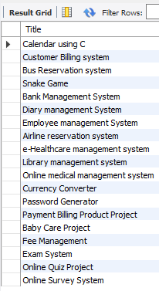

51)Display the names and ages of all the programmers who have undergone training in DCS course.

**QUERIES-II**

1)Display THE NUMBER OF packages developed in EACH language.

SELECT Dev_in AS Language,COUNT(Title) No_of_Packages FROM software GROUP BY Dev_in;

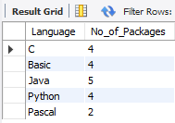

2) Display THE NUMBER OF packages developed by EACH person.

 SELECT Programmer_name,COUNT(Title) No_of_Packages FROM software GROUP BY Programmer_name;

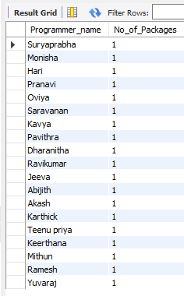

3) Display THE NUMBER OF male and female programmer.

 SELECT Sex,COUNT(Programmer_name) FROM programmer GROUP BY Sex;

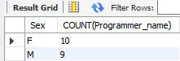

4) Display THE COSTLIEST packages and HIGEST selling developed in EACH language.

 SELECT Dev_in,MAX(scost) AS Costliest,MAX(sold) AS Maximum_sold FROM software GROUP BY Dev_in;

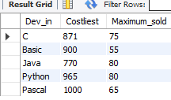

5) Display THE NUMBER OF people BORN in EACH YEAR.

SELECT YEAR(DOB) AS YEAR,COUNT(Programmer_name) FROM programmer GROUP BY YEAR(DOB);

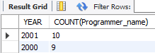

6) Display THE NUMBER OF people JOINED in EACH YEAR.

SELECT YEAR(DOJ) AS JOINED_YEAR,COUNT(Programmer_name) FROM programmer GROUP BY YEAR(DOJ);

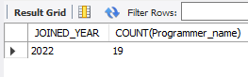

7) Display THE NUMBER OF people BORN in EACH MONTH.

SELECT MONTH(DOB),COUNT(Programmer_name) FROM programmer GROUP BY MONTH(DOB);

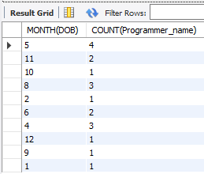

8) Display THE NUMBER OF people JOINED in EACH MONTH.

SELECT MONTH(DOJ),COUNT(Programmer_name) FROM programmer GROUP BY MONTH(DOJ);

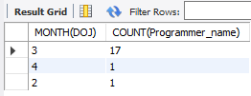

9) Display the language wise COUNTS of Language1.

SELECT Language1, COUNT(Language1) FROM programmer GROUP BY Language1;

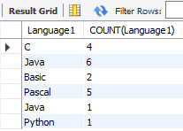

10) Display the language wise COUNTS of Language2.

SELECT Language2, COUNT(Language2) FROM programmer GROUP BY Language2;

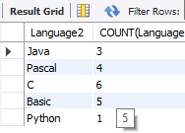

11) Display THE NUMBER OF people in EACH salary group.

SELECT SALARY,COUNT(NAME) FROM PROGRAMMER GROUP BY SALARY;

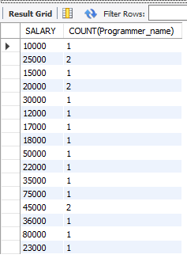

12) Display THE NUMBER OF people who studied in EACH institute.

SELECT splace, COUNT(Programmer_name) FROM studies GROUP BY splace;

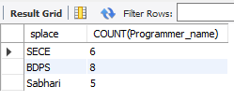

13) Display THE NUMBER OF people who studied in EACH course.

SELECT course , COUNT(Programmer_name) FROM studies GROUP BY course;

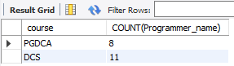

14) Display the TOTAL development COST of the packages developed in EACH language.

SELECT DEV_IN LANG,SUM(DCOST) TOTAL_COST FROM SOFTWARE GROUP BY DEV_IN;

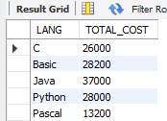

15) Display the selling cost of the package developed in EACH language.

SELECT Dev_in ,SUM(scost) AS Selling_cost FROM software GROUP BY Dev_in;

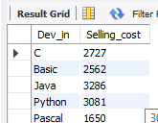

16) Display the cost of the package developed by EACH programmer.

 SELECT Programmer_name,SUM(dcost) AS TOTAL_COST FROM software GROUP BY Programmer_name;

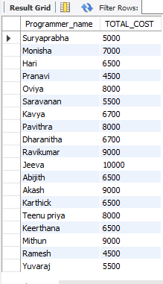

17) Display the sales values of the package developed in EACH programmer.

 SELECT NAME, SUM(SCOST*SOLD) FROM SOFTWARE GROUP BY NAME;

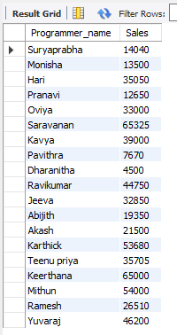

18) Display the NUMBER of packages developed by EACH programmer.

SELECT Programmer_name,COUNT(Title) AS TOTAL_PACK FROM software GROUP BY Programmer_name;

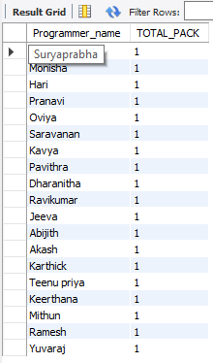

19) Display the sales COST of packages developed by EACH programmer language wise.

 SELECT DEV_IN, SUM(SCOST) FROM SOFTWARE GROUP BY DEV_IN;

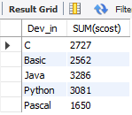

20) Display EACH programmers name,costliest package,cheapest packages developed by His/Her?

SELECT Programmer_name,MIN(dcost),MAX(dcost)FROM software GROUP BY Programmer_name;

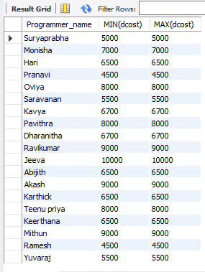

21) Display EACH language name with AVERAGE development cost, AVERAGE cost, selling

cost and AVERAGE price per copy.

 SELECT DEV_IN,AVG(DCOST),AVG(SCOST),AVG(SCOST) FROM SOFTWARE GROUP BY DEV_IN;

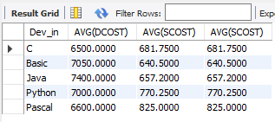

22) Display EACH institute name with NUMBER of courses, AVERAGE cost per course.

 SELECT SPLACE,COUNT(COURSE), AVG(CCOST) FROM STUDIES GROUP BY SPLACE;

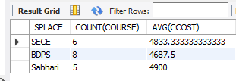

23) Display EACH institute name with NUMBER of students.

 SELECT SPLACE,COUNT(Programmer_name) FROM STUDIES GROUP BY SPLACE;

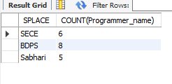

24) Display names of male and female programmers.

 SELECT Programmer_name,SEX FROM PROGRAMMER ORDER BY SEX;

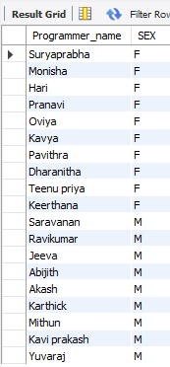

25) Display the programmer's name and their packages.

 SELECT Programmer_name, TITLE FROM SOFTWARE ORDER BY Programmer_name;

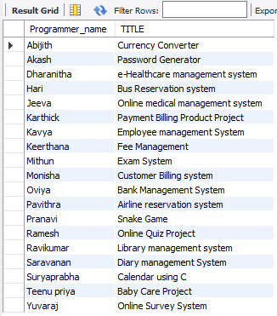

26) Display the NUMBER of packages in EACH language.

 SELECT COUNT(TITLE),DEV_IN FROM SOFTWARE GROUP BY DEV_IN;

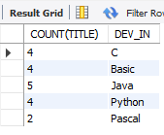

27) Display the NUMBER of packages in EACH language for which development cost is less than

1000.

 SELECT COUNT(TITLE),DEV_IN FROM SOFTWARE WHERE DCOST<1000 GROUP BY DEV_IN;

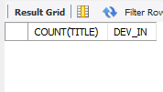

28) Display the AVERAGE difference BETWEEN scost and dcost for EACH language.

SELECT DEV_IN,AVG(DCOST - SCOST) FROM SOFTWARE GROUP BY DEV_IN;

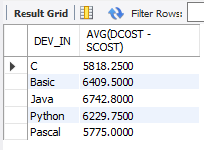

29) Display the TOTAL scost, dcsot and amount TOBE recovered for EACH programmer for

whose dcost HAS NOT YET BEEN recovered.

SELECT SUM(SCOST), SUM(DCOST), SUM(DCOST-(SOLD*SCOST)) FROM SOFTWARE GROUP BY NAME HAVING SUM(DCOST)>SUM(SOLD*SCOST);

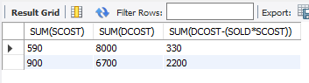

30) Display highest, lowest and average salaries for THOSE earning MORE than 2000.

SELECT MAX(SALARY), MIN(SALARY), AVG(SALARY) FROM PROGRAMMER WHERE SALARY > 2000;

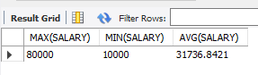

**QUERIES-III**

1) Who is the highest paid C programmer?

SELECT * FROM PROGRAMMER WHERE SALARY=(SELECT MAX(SALARY) FROM PROGRAMMER WHERE PROF1 LIKE 'C' OR PROF2 LIKE 'C');

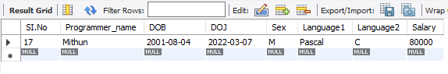

2) Who is the highest paid female cobol programmer?

SELECT * FROM PROGRAMMER WHERE SALARY=(SELECT MAX(SALARY) FROM PROGRAMMER WHERE (PROF1 LIKE 'COBOL' OR PROF2 LIKE 'COBOL')) AND SEX LIKE 'F';

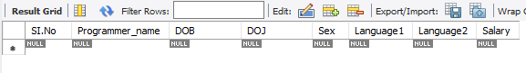

3) Display the name of the HIGEST paid programmer for EACH language (Language1)

SELECT DISTINCT NAME, SALARY, PROF1  
FROM PROGRAMMER  
WHERE (SALARY,PROF1) IN (SELECT MAX(SALARY),PROF1  
FROM PROGRAMMER  
GROUP BY PROF1)

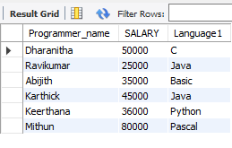

4) Who is the LEAST experienced programmer?

SELECT FLOOR(DATEDIFF(CURDATE(),DOJ)/365) Experienced,Programmer_name FROM PROGRAMMER WHERE FLOOR(DATEDIFF(CURDATE(),DOJ)/365) = (SELECT MIN(FLOOR(DATEDIFF(CURDATE(),DOJ)/365)) FROM PROGRAMMER);

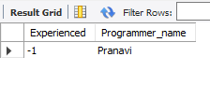

5) Who is the MOST experienced programmer?

SELECT FLOOR((SYSDATE-DOJ)/365) EXP,NAME,PROF1,PROF2 FROM PROGRAMMER WHERE FLOOR((SYSDATE-DOJ)/365) = (SELECT MAX(FLOOR((SYSDATE-DOJ)/365)) FROM PROGRAMMER);

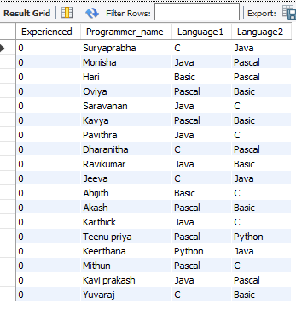

6) Which language is known by ONLY ONE programmer?

SELECT Language1 FROM PROGRAMMER GROUP BY Language1 HAVING LAnguage1 NOT IN (SELECT Language2 FROM PROGRAMMER) AND COUNT(Language1)=1 UNION SELECT Language2 FROM PROGRAMMER GROUP BY Language2 HAVING Language2 NOT IN (SELECT Language1 FROM PROGRAMMER) AND COUNT(Language1)=1;

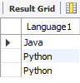

7) Who is the YONGEST programmer knowing DBASE?

SELECT FLOOR((SYSDATE-DOB)/365) AGE, NAME, PROF1, PROF2  
FROM PROGRAMMER  
WHERE FLOOR((SYSDATE-DOB)/365) = (SELECT MIN(FLOOR((SYSDATE-DOB)/365))  
FROM PROGRAMMER  
WHERE PROF1 LIKE 'DBASE' OR PROF2 LIKE 'DBASE')

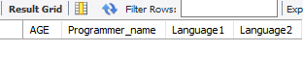

8) Which institute has MOST NUMBER of students?

SELECT MAX(SPLACE) FROM STUDIES;



9) Which female programmer earns MORE than 3000/- but DOES NOT know C, C++, Oracle or Dbase?

SELECT * FROM PROGRAMMER WHERE SEX = 'F' AND SALARY >3000 AND (PROF1 NOT IN('C','C++','ORACLE','DBASE') OR PROF2 NOT IN('C','C++','ORACLE','DBASE'));

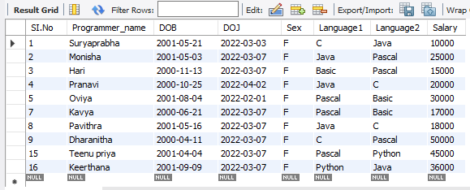

10) Which is the COSTLIEST course?

SELECT DISTINCT COURSE FROM STUDIES WHERE CCOST = (SELECT MAX(CCOST) FROM STUDIES);

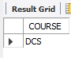

11) Which course has been done by MOST of the students?

SELECT COURSE FROM STUDIES GROUP BY COURSE HAVING COUNT(COURSE)= (SELECT MAX(COUNT(COURSE)) FROM STUDIES GROUP BY COURSE);

12) Display name of the institute and course Which has below AVERAGE course fee?

SELECT SPLACE,COURSE FROM STUDIES WHERE CCOST < (SELECT AVG(CCOST) FROM STUDIES);

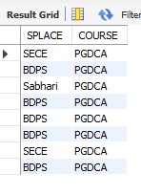

13) Which institute conducts COSTLIEST course?

SELECT SPLACE FROM STUDIES WHERE CCOST = (SELECT MAX(CCOST) FROM STUDIES);

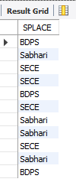

14) Which course has below AVERAGE number of students?

SELECT COURSE FROM STUDIES GROUP BY COURSE HAVING COUNT(Programmer_name)<(SELECT AVG(COUNT(Programmer_name)) FROM STUDIES GROUP BY COURSE) ;

15) Which institute conducts the above course?

SELECT SPLACE FROM STUDIES WHERE COURSE IN (SELECT COURSE FROM STUDIES GROUP BY COURSE HAVING COUNT(NAME) < (SELECT AVG(COUNT(NAME)) FROM STUDIES GROUP BY COURSE));

16) Display names of the course WHOSE fees are within 1000(+ or -) of the AVERAGE fee.

SELECT COURSE FROM STUDIES WHERE CCOST < (SELECT AVG(CCOST)+1000 FROM STUDIES) AND CCOST > (SELECT AVG(CCOST)-1000 FROM STUDIES);

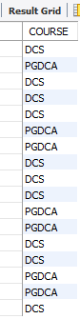

17) Which package has the HIGEST development cost?

SELECT TITLE,DCOST FROM SOFTWARE WHERE DCOST = (SELECT MAX(DCOST) FROM SOFTWARE);

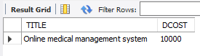

18) Which package has the LOWEST selling cost?

SELECT TITLE,SCOST FROM SOFTWARE WHERE SCOST = (SELECT MIN(SCOST) FROM SOFTWARE);

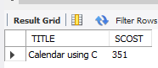

19) Who developed the package, which has sold the LEAST number of copies?

SELECT NAME,SOLD FROM SOFTWARE WHERE SOLD = (SELECT MIN(SOLD) FROM SOFTWARE);

SELECT NAME,SOLD FROM SOFTWARE WHERE SOLD = (SELECT MIN(SOLD) FROM SOFTWARE);

20) Which language was used to develop the package WHICH has the HIGEST sales amount?

SELECT DEV_IN,SCOST FROM SOFTWARE WHERE SCOST = (SELECT MAX(SCOST) FROM SOFTWARE);

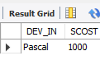

21) How many copies of the package that has the LEAST DIFFRENCE between development and selling cost were sold?

SELECT SOLD,TITLE FROM SOFTWARE WHERE TITLE = (SELECT TITLE FROM SOFTWARE WHERE (DCOST-SCOST)=(SELECT MIN(DCOST-SCOST) FROM SOFTWARE);

22) Which is the COSTLIEAST package developed in PASCAL?

SELECT TITLE FROM SOFTWARE WHERE DCOST = (SELECT MAX(DCOST) FROM SOFTWARE WHERE DEV_IN LIKE 'PASCAL');

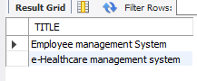

23) Which language was used to develop the MOST NUMBER of package?

SELECT DEV_IN FROM SOFTWARE GROUP BY DEV_IN HAVING MAX(DEV_IN) = (SELECT MAX(DEV_IN) FROM SOFTWARE);



24) Which programmer has developed the HIGEST NUMBER of package?

SELECT NAME FROM SOFTWARE GROUP BY NAME HAVING MAX(NAME) = (SELECT MAX(NAME) FROM SOFTWARE);

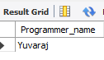

25) Who is the author of the COSTLIEST package?

SELECT NAME,DCOST FROM SOFTWARE WHERE DCOST = (SELECT MAX(DCOST) FROM   SOFTWARE);



26) Display names of packages WHICH have been sold LESS THAN the AVERAGE number of copies?

SELECT TITLE FROM SOFTWARE WHERE SOLD < (SELECT AVG(SOLD) FROM SOFTWARE);

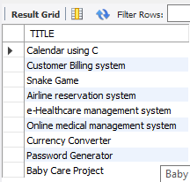

27) Who are the female programmers earning MORE than the HIGEST paid male programmers?

SELECT NAME FROM PROGRAMMER WHERE SEX = 'F' AND SALARY > (SELECT(MAX(SALARY)) FROM PROGRAMMER WHERE SEX = 'M');



28) Which language has been stated as prof1 by MOST of the programmers?

SELECT PROF1 FROM PROGRAMMER GROUP BY PROF1 HAVING PROF1 = (SELECT MAX(PROF1) FROM PROGRAMMER);



29) Who are the authors of packages, WHICH have recovered MORE THAN double the development cost?

SELECT NAME FROM SOFTWARE WHERE SOLD*SCOST > 2*DCOST;

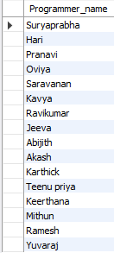

30) Display programmer names and CHEAPEST package developed by them in EACH

language?

SELECT NAME,TITLE FROM SOFTWARE WHERE DCOST IN (SELECT MIN(DCOST) FROM SOFTWARE GROUP BY DEV_IN);

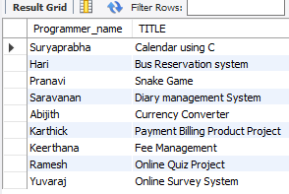

31) Who is the YOUNGEST male programmer born in 1965?

SELECT NAME FROM PROGRAMMER WHERE DOB=(SELECT (MAX(DOB)) FROM PROGRAMMER WHERE YEAR(DOB) LIKE '1965');

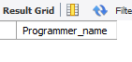

32) Display language used by EACH programmer to develop the HIGEST selling and LOWEST selling package.

SELECT Programmer_name, DEV_IN FROM SOFTWARE WHERE SOLD IN (SELECT MAX(SOLD) FROM SOFTWARE GROUP BY Programmer_name) UNION SELECT Programmer_name, DEV_IN FROM SOFTWARE WHERE SOLD IN (SELECT MIN(SOLD) FROM SOFTWARE GROUP BY Programmer_name);

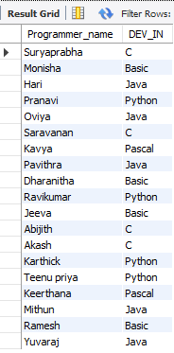

33) Who is the OLDEST female programmer WHO joined in 1992?

SELECT Programmer_name FROM PROGRAMMER WHERE DOJ=(SELECT (MIN(DOJ)) FROM PROGRAMMER WHERE YEAR(DOJ) LIKE '1992');

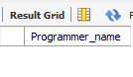

34) In WHICH year where the MOST NUMBER of programmer born?

SELECT DISTINCT YEAR(DOB) FROM PROGRAMMER WHERE YEAR(DOJ) = (SELECT MIN(YEAR(DOJ)) FROM PROGRAMMER);

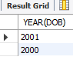

35) In WHICH month did MOST NUMBRER of programmer join?

SELECT DISTINCT MONTH(DOJ) FROM PROGRAMMER WHERE MONTH(DOJ) = (SELECT MIN(MONTH(DOJ)) FROM PROGRAMMER);

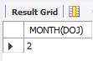

36) In WHICH language are MOST of the programmer's proficient?

SELECT PROF1 FROM PROGRAMMER GROUP BY PROF1 HAVING COUNT(PROF1)=(SELECT  MAX(COUNT(PROF1)) FROM PROGRAMMER GROUP BY PROF1) OR COUNT(PROF2)=(SELECT MAX(COUNT(PROF2)) FROM PROGRAMMER GROUP BY PROF2)

UNION

SELECT PROF2 FROM PROGRAMMER GROUP BY PROF2 HAVING COUNT(PROF1)=(SELECT MAX(COUNT(PROF1)) FROM PROGRAMMER   GROUP BY PROF1) OR COUNT(PROF2)=(SELECT MAX(COUNT(PROF2)) FROM PROGRAMMERGROUP BY PROF2);

37) Who are the male programmers earning BELOW the AVERAGE salary of female

programmers?

SELECT Programmer_name FROM PROGRAMMER WHERE SEX = 'M' AND SALARY < (SELECT(AVG(SALARY))FROM PROGRAMMER WHERE SEX = 'F');

